**Working of Arduino UNO with Gas sensor MQ8**

**Diagram**

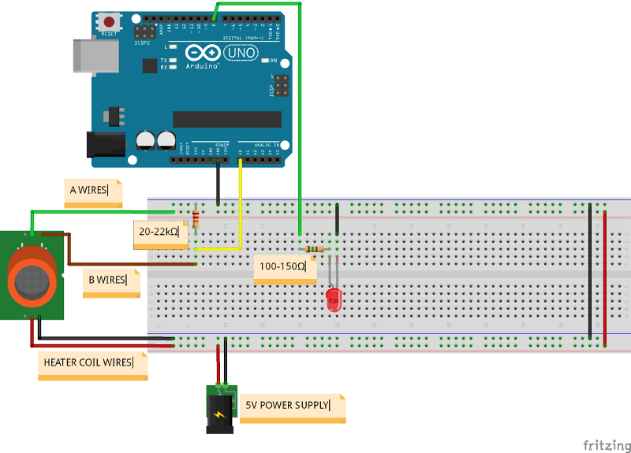

**Working**

We are required to interface a GAS sensor with Arduino. This gas sensor detects Hydrogen gas (read data sheet attached in the git hub file). If quantity of Hydrogen gas exceeds a specific ppm it generates an led red warning.

**Important**

->Resistors are important to use without them sensor will burn

-> There is no hard of fast pin configuration, it would be easy to watch a relevant video instead of the schematic.

-> Adding more delay to code can be important at time.

-> Use a lighter to check change in result make sure its flaming side is at sensor